Learning Activity Types (LAT) Lesson Planning Guide

Use this guide with the process described in the LAT Short Course and the article Grounded Tech Integration in planning one technology-integrated lesson in your preferred grade level and subject area.

- Instructional Context
Grade Level: 6 | Content Area: Math
1a. Texas Essential Knowledge and Skills (TEKS) (copy and paste 1-3 standards):

Mathematical process standards. The student uses mathematical processes to acquire and demonstrate mathematical understanding. The student is expected to:
(C) select tools, including real objects, manipulatives, paper and pencil, and technology as appropriate, and techniques, including mental math, estimation, and number sense as appropriate, to solve problems.
Probability and statistics. The student uses statistical representations to analyze data.
(A) select and use an appropriate representation for presenting and displaying different graphical representations of the same data including line plot, line graph, bar graph, and stem and leaf plot;
(D) solve problems by collecting, organizing, displaying, and interpreting data.

1b. Specific learning goals/objectives for the students, using specific verbs that identify what the students will know or be able to do as a result of the lesson:

- The students will be able to use estimation strategies and determine the accuracy of their estimates.
- The students will be able to record, organize, display, and analyze data that they have collected.
- The students will be able to identify different kinds of graphs and use technology to create at least two graphs to represent their data.

For step 2, follow the Elementary or Secondary LAT short course module 6, found under more…)

- Pedagogical Continua
Move the red dots to the place on each line to indicate the anticipated contextual conditions of your lesson.  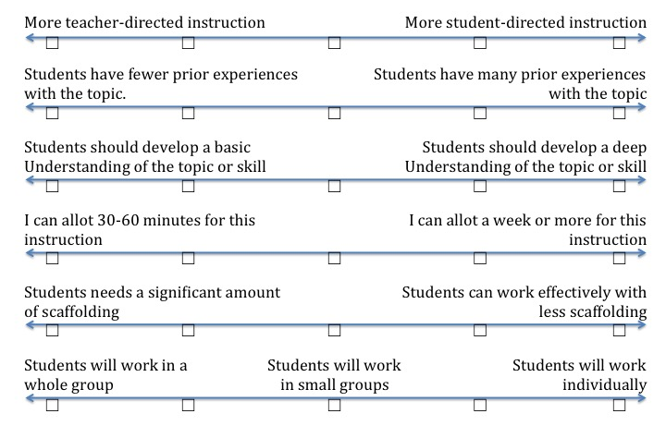 | Notes: By sixth grade, students should have familiarity with making and interpreting different kinds of graphs. However, they may still be unsure about which types of graphs are appropriate for different kinds of data. They have recently learned how to calculate averages and percentages, so students may need some reminders about how to do so. This lesson should take 1-2 class periods. Students can work in small groups so that they can help each other out.

For steps 3a, 3b, and 3c, follow the Elementary or Secondary LAT short course modules 7 and 8, found under more…)

3a. Learning Goal Classification and Taxonomy Exploration
Learning Goal (from step 1b) | Content or Process Focus? | Relevant Taxonomy Sub-Heading(s)
The students will be able to use estimation strategies and determine the accuracy of their estimates. | Process | Math – Interpret, Evaluate
The students will be able to record, organize, display, and analyze data that they have collected. | Process | Math – Interpret, Produce
The students will be able to identify different kinds of graphs and use technology to create at least two graphs to represent their data. | Content and Process | Math - Produce

3b. LAT and Technology Selections
Learning Goal (from step 1b) | Possible LATs | Selected LATs | Possible Technologies | Selected Technologies
The students will be able to use estimation strategies and determine the accuracy of their estimates. | Estimate, Compare and Contrast, Interpret a Representation | Estimate, Compare and Contrast | Calculator, spreadsheet, graphic organizer | Calculator
The students will be able to record, organize, display, and analyze data that they have collected. | Categorize, Interpret a Representation, Generate Text, Develop a Problem, Produce a Representation | Categorize, Produce a Representation | Spreadsheet, word processor, graphic organizer | Spreadsheet (Google Sheets)
The students will be able to identify different kinds of graphs and use technology to create at least two graphs to represent their data. | Produce a Representation, Generate Text, Describe an Object or Concept Mathematically | Produce a Representation | Spreadsheet, online graphing program | Online graphing program (Create A Graph)

3c. Final Sequence of LATs and Technologies
LATs (List the selected LATs in logical order)  - Estimate  - Produce a representation (chart)  - Categorize  - Compare and Contrast  - Produce a representation (graph) | Materials (List digital technologies and non-digital items needed)  Calculator, pencil, paper (graph paper), rulers, written step-by-step directions, small bags of multi-colored candy (e.g., M&Ms), plastic bags, laptop computer, internet access, Google Sheets, online graphing program (Create A Graph)

3d. Relative Advantage
Describe the relative advantage of using technology in the lesson (i.e., how the technology selected would help students better meet both the TEKS and the ISTE standards).

Using technology allows students to neatly organize their data and create graphs. It is faster, creates more professional looking products, improves accuracy, and supports cooperative group work. While students could use a spreadsheet to create graphs, Create A Graph is a bit easier to use than a spreadsheet program and it allows students to easily try out different kinds of graphs.

4. Procedure
From the LATs listed in step 3c, describe in your own words the steps that the teacher and students would follow when engaging in the activities. Try to include options that provide multiple means of representation, expression, and engagement.

- Place students in groups of about 4 students each.
- Explain the roles of each group member and have each student pick a role (principle investigator, materials manager, recorder, and reporter).
- Provide an overview of the directions orally and also provide a list of step-by-step written directions. The teacher should circulate around the room to assist students as they complete each step.
- Pose questions about what is in a bag of candy with regard to color, number, and similarity among the bags.
- Discuss different strategies students could use to make a good estimate. Then, have students estimate what is in the bag (how many of each color and the total). The recorder should make a chart and record the estimates. If necessary, the teacher may demonstrate how to make a chart.
- Next, students open the bag of candy and pour the candy into a zip lock bag. Students should categorize the candy by color and count the number of each color. The recorder should write the actual numbers for each candy on a chart.
- Students should compare and contrast their estimates and actual number of each color of candy. They can use calculators to find the difference or they can draw a double bar chart to illustrate the differences between the estimated and actual amount.
- Using a pre-made Google Sheet that is shared with the students, have the reporters enter the number of each color in their bag.
- The teacher demonstrates how to calculate total number of candies per bag, as well as averages and percentages of each color. (In a future lesson, the students will have an opportunity to do these calculations themselves.) Discuss the interpretation of these calculations (e.g., the most and least common colors).
- Next the students will make a graph of the average number of each color shown on the spreadsheet. Demonstrate how to use the Create A Graph website to create a pie chart and how to switch between different kinds of graphs. Discuss the most appropriate graphs for the data (e.g., pie or bar). Have students identify the type of graph in the title of the graph (e.g., Pie Graph of M&M colors). Students should print out their graphs when finished.

5. Assessment
Identify one or more assessment strategies (e.g., rubric, checklist, quiz, test, etc.) that could be used to evaluate whether the students have met the lesson objectives. Be sure that the assessment method is consistent with the objectives and procedures.

Use a checklist to determine whether students (1) correctly created a chart showing their estimates and actual amounts of each color candy, (2) used an effective strategy to compare their estimates to the actual amount, (3) created two different kinds of graphs (pie, bar) and labeled them accurately (identifying the type of graph in the title of the graph)

Before turning in this draft of your lesson plan, use the check list below to self-assess your work. By doing so, you can avoid having to redo your work later!

- Before turning in this draft of your lesson plan, use the checklist below to self-assess your work. By doing so, you can avoid having to redo your work later!

_X__Objectives are aligned with the Texas Essential Knowledge and Skills (TEKS), providing clear statements of observable student behaviors that demonstrate learning. (Step 1)

_X__ Pedagogical decisions are appropriate and are reflected in activities and materials selected. (Steps 2-5)

_X__ Multiple potential activity types, technologies, and other non-digital materials are listed. (Step 3)

_X__The technology and other materials selected are appropriate and offer clear relative advantage over options. (Step 3)

_X__The activities and technologies selected are essential to helping students accomplish the lesson objectives and the standards with which they are aligned. (Step 1 and 3)

_X__Procedures provide options for multiple means of representation, expression, and engagement, when possible. (Step 4)

_X__ Procedures are described in sufficient detail and in your own words. (Step 4)

_X__There is a good match between objectives and assessments. (Steps 1 & 5)

